New Life SDA Church
Volume 1, Issue 1 November 2017
What’s New @ New Life
New Life now has an online member directory: http://directory.instantchurchdirectory.com/74038796/churchdirectory.pdf
If you would like to add a photo of you or a family member, please contact email Sister F. Cobbs at feliciacobbs9@aol.com and put “directory photo” in subject line.

Marriage Corner:
Happy Anniversary Michael & Gail DePriest!
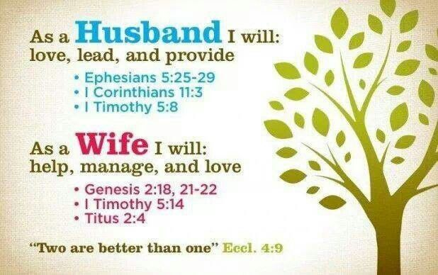

New Members:
Please join me today in welcoming the Narlene Hollingsworth & Aquailia Ramsey to the New Life congregation. We look forward to getting to know both families better in the near future. If you have not met them yet, please introduce yourself and welcome them to the New Life Church Family.

Pastor’s Corner
I would like to say what a joy and honor it is to be the pastor of New Life SDA Church. The Lord has been so good to us, he has blessed us in so many ways. The Lord has shown Himself, strong and mighty "To God Be the Glory." For the things that have happened in 2017 and allowing me to pastor this church, it is truly the work of the Lord. I want to thank the Lord for the wonderful people He has led this way to be a part of this great work here in Marion, AR. We have some great people, and the Lord continues to add to the church. People that love each other, serve each other, and have a labor of love. As pastor I want to say "thank you," and I love all of you very much. I praise the Lord for the Spirit-Led, Spirit-Filled, and Spirit-Feed services, thank God for His presence.

I want to encourage the members of New Life Church to always keep "Jesus First" in all the work we do for Him, always pray for the leadership of the Lord in the ministry our church. Once again thanks for allowing me to be your Pastor, all of you are a real blessing to me and my wife. God has proved Himself faithful so many times, and that we are doing what God called and laid on our hearts to do.

I Peter 5:7 - Always In His Service

Pastor Charles E. Cunningham

Youth Spotlight:
Sarai Ivey:
Saria was a volunteer for drug free month with Red Ribbon. Her grades have improved to A’s and B’s with only 1 C. Saria is working on a project of rewriting the whole constitution for her Civics class. She is a member of her school choir and they will be in concert on Dec. 5, 2017 @ 7 pm at Marion High School performing Arts Center.
Jaylan Cobbs:
Jaylan has continued to stay allthe honor roll the first semester of her 11th grade year. Jaylan also received her BLS certification in October 2017.
Daisha Campbell:
Daisha is in her second year of college and has received an “A” in each course. Great Job Daisha!
Conrad Small:
Mr. Woo has showed out in the month of October and showed us another one of his talents….Conrad took time to not only help his mom to send out birthday cards in the month of October…but he wrote a special note to each celebrant and touched their hearts in ways he will never know. Thanks Conrad for allowing God to use you!

Adult Spotlight:
Mr. & Mrs Phillip Cobbs welcomed their new grandson Bryson Kai Jamal Smith to the world on October 14, 2017

SDA Fundamental belief # 1:
The Holy Scriptures, Old and New Testaments, are the written Word of God, given by divine inspiration. The inspired authors spoke and wrote as they were moved by the Holy Spirit. In this Word, God has committed to humanity the knowledge necessary for salvation. The Holy Scriptures are the supreme, authoritative, and the infallible revelation of His will. They are the standard of character, the test of experience, the definitive revealer of doctrines, and the trustworthy record of God’s acts in history. (Ps. 119:105; Prov. 30:5, 6; Isa. 8:20; John 17:17; 1 Thess. 2:13; 2 Tim. 3:16, 17; Heb. 4:12; 2 Peter 1:20, 21.)

The New Life Church Family would like to wish our November celebrants a happy & blessed birthday!
Jamie Small 11th
Jeff Ivey 17th
Jeremani Stafford- 25th
Royal Davis-25th

continued on page 2

Inside This Issue
1 | Pastors Corner
1 | Youth Spotlight
1 | Marriage Corner
continued on page 3

continued from page 1

Calendar of Events
Bible Study/prayer meeting
1093 Highway 77, Marion AR 72364
5:00 p.m.
“Studying to show ourselves approved”
.

